Ideation Phase

Define the Problem Statements

|  |  |
| --- | --- |
| Date | 25 September 2022 |
| Team ID | PNT2022TMID54269 |
| Project Name | Project - car resale value prediction |
| Maximum Marks | 2 Marks |

Problem statement 1:

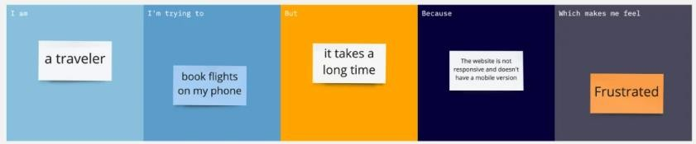

Problem statement 2:



|  |  |  |  |  |  |
| --- | --- | --- | --- | --- | --- |
| **Problem**  **Statement (PS)** | **I am**  **(Customer)** | **I’m trying to** | **But** | **Because** | **Which makes me feel** |
| PS-1 | customer | Buy a car | Not able to  Look correct  Information  Of a car | Of not correct data | Sad |
| PS-2 | Show room  owner | Find best selling  Car brand | Couldn’t find  Correct one | Lack of important  information | Frustrated |